

ACCORD CO., LTD.

8TH FL., 398, JEN AI ROAD, SEC. 4, TAIPEI, TAIWAN

TEL:886-2-27044503

FAX:886-2-27036358 , 27044593
E-mail: accord@accordia.com.tw
http://www.accordia.com.tw

RE: AK-1607-N-BBY-WP-MM
The keypad finish is black baking paint

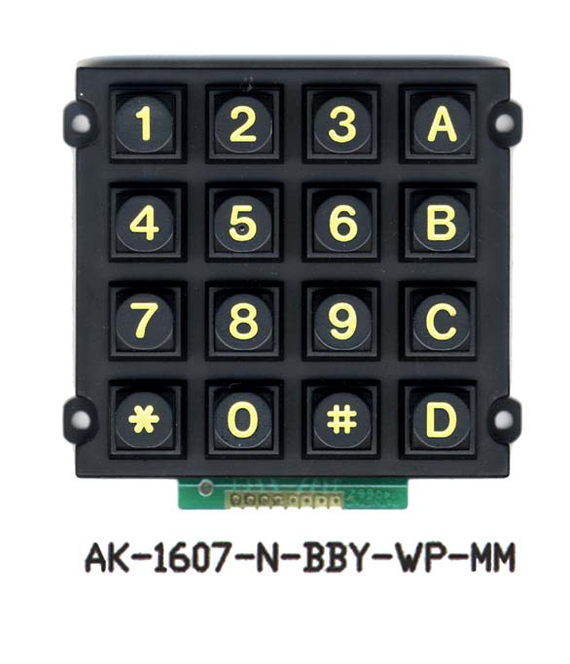
CONTENTS:

- POLYESTER RESIN
- MELAMINE RESIN
- EPOXY RESIN
- CARBON BLACK
- FILLER
- ORGANIC SOLVENT
- AUXLIARY

The baking paint (coating) can stand the test for salt water spraying over 72 hours.
This keypad can meet the military specification.

